Thornbury Running Club
AGM Minutes – compiled 15/05/2026
Thursday 14th May 2026 8:00pm at Thornbury Cricket Club
Present: A total 0f 59 members attended the meeting
Apologies: None
Action |  | Owner
2.1 | 2. Chairman’s opening remarks:  - The Chairman gave a welcome and some opening remarks
3.1 | 3. Secretary’s Report:  - The Secretary gave his report (see appendix 1)
4.1 | 4. Treasurers Report:  - The Treasurer gave his report (see Appendix 2)
5.1 | 5. Captain’s Report:  - The Captain gave his report (see Appendix 3)
6.1 | 6. Election of Club Officers and Committee:  - The Club Officers and Committee members were re-elected en masse –. The committee and officers are as last year with the following change  - Addition of Claire Hollingdale. The chairman welcomed her onto the committee
7.1 | 7. Selection of club charity for 2026/2027  - The Secretary had received two proposals for next year’s charitable cause which were circulated to the meeting, These were then voted upon with the following result  - Brain Tumour Support – 36 votes  - Krunch Southwest – 16 votes  - It was therefore decided by the meeting to adopt Brain Tumour Support as the charitable cause.
 | 8 AOB: None
Meeting ended 20:32

Appendix 1 – Secretary’s Report
The Committee has met on 7 occasions during this period. We meet after a club night at The Swan, who kindly give us the use of their function room in exchange for a donation to their charity fund, The main items addressed by the committee were club races (organisation and medals), club kit (purchase and sale of new design kit and disposal of old kit) and social events.
Membership currently (as of May 7th) stands at 156 members (compares with 154 at the same time last year). Of these we have 96 men and 60 women, and we have 38 new members who have joined in 2026.
Of these, 56 members have taken out individual England Athletics membership, which guarantees the club a place in the London Marathon.
EA/ARC affiliation The Club continues to be affiliated to England Athletics, the Association of Running Clubs and the Avon Athletic Association. We also continue to be members of the Cotswold Way Association and the Ramblers Association.
Club Races
The three club races were very successful again this year thanks to the efforts of our Race Directors and the many volunteer helpers.
Social Events
We held some well attended Run and Rehydrate events; a Christmas Lights run and the AGM at the Cricket Club and Jo has also provided post-race refreshments for Pete Mainstone Challenge races. A summer BBQ was held at Thornbury Cricket Club for members and their families.
Club Charity
The club charities for 2025/2026 (which received an equal number of votes) were Addisons Disease Support and The Grand Appeal. Each charity will receive £1000 from the Club. We have received two proposals for the 2026/2027 charitable cause. We will decide by means of a vote at this meeting which of these will be selected.
Nigel Hale – May 2026

Appendix 2 – Treasurer’s Report
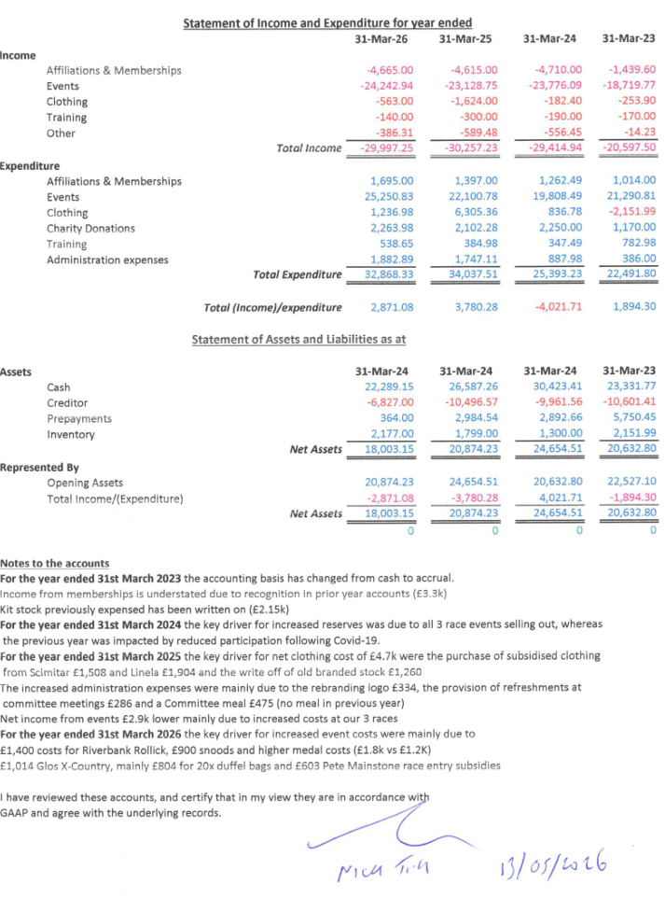

Appendix 3 – Captain’s Report
It gives me great pleasure to deliver my captains report for 2025 to 2026.
I will start with the Tuesday coached sessions - with particular thanks to our coaches, Nick Williams, Hannah Hamilton and Peter Cable without whom the sessions would not be possible. These sessions have proved very popular with those training for specific events or just wanting to improve their speed or distance. I would like to take this opportunity to remind the members that these sessions are open to all ability levels.
On Wednesdays we often have our beginners sessions - thanks to Carol Mosses for organising and to all the volunteers.
Our regular Thursday club nights continue to be very well attended - despite the leisure centre’s attempts to keep the doors locked - with up to six differently paced groups being led by our amazing team of run leaders. My thanks go to the run leaders for planning routes around Thornbury and making sure that everyone gets back safely. Thanks also to Val James for her tireless dedication in setting up the tea, leading the walking group and then clearing up every single week. Three other thanks go to Arthur Renshaw for organising the tea rota, Ben Foss for organising the leaders rota and Mel Lloyd for sending me the run results.
The Pete Mainstone Challenge for 2025 had some very well attended races - thanks to Jo Plumbley for organising the events and bringing well-deserved refreshments. The events were the Weston Prom 5 miler, Hogweed Trot 10k, Woodchester Park trail 10k and our own club road race champs. The overall winners were Ben Bohane and Hannah Hamilton with Nick Langridge and Mel Wilson winning the age-adjusted prizes. This year’s competition has already started at Woodchester and continues next week at the Weston prom.
As part of the Pete Mainstone Challenge the club road race champs saw the closest of finishes when Nick Williams pipped Phil Blackburn by less than a second. Hannah Hamilton took the ladies first place.
The cross country season had some excellent individual results but the club managed to somehow often be one short in team competitions. Congratulations to Hannah Hamilton and Sam Bainbridge who were our highest finishers overall, with notable age group achievements for Catherine Dack -4th, Ros Rowlands 3rd, Nick Langridge 2nd, Matt Johnstone 5th and Martyn Green 5th. Continuing the off-road theme we had a male and a female team in the Cotswold way relay with the best individual result being George Evans who was third on leg 3.
This year’s club place at the London Marathon was awarded to Mel Wilson with Pete Cable having the club place that had been deferred from the previous year. They were joined by six other Thornbury runners with Phil Blackburn first home in 2:40. It would be amiss to not mention the amazing other results that Phil has had this year in taking the club parkrun record of 16:18 at Batttersea, the club 10 mile record of 54:34, the half-marathon record of 1:10: 55 at Gloucester and the club marathon record of 2:39:54 at Abingdon.
I do not have time to mention all the impressive results this year so apologies if I have missed you out, but it has been wonderful to see so many Thornbury vests out at local parkruns, 10ks, hilly and flat half and full marathons and even the odd ultra.
I am a great supporter of parkrun so I was delighted that the club agreed to make a donation to help establish a new junior parkrun in Thornbury which is hopefully starting soon and will feed young runners in to the senior parkrun and then hopefully the running club.
Many of us enjoy pushing ourselves and setting challenges. For some this is club records, medals, personal bests, longer distances, international events, wine-based marathons or parkrun percentages. For others it is the desire to be fitter and healthier. This club is obviously about running - the clue is in our name - but I know that for many of you it is about so much more than running - a supportive environment where the gentle encouragement of friends means that it is not just your physical side being nourished but your emotional side too.
My final thanks go to all of the committee for their hard work, to the race organisers, that is Colette Jackson for the 10k, Pete Cable for the 10 mile and Jim Godden for the Rollick - without whose time and effort the races would not be such a success and indeed thanks to anyone who has volunteered at any of our events or the beginners courses over the last year
I look forward to another successful year ahead.
Moray Sloan

