Thornbury Running Club AGM
Thursday 2nd February 2017
At Thornbury Leisure Centre

Present: Craig Carscadden, Hugh McPherson, Arthur Renshaw, Steve Dimond, Emma Barnes, Ros Rowland, John Watt, Jim Godden, Pete Mainstone, Kevin Cundy, Rob Watkins, Suzy Cundy, Jo Plumbley, Selina Slater, Malcolm Carr, Karen Carr, Val James, Jerry Clothier, Judy Mills, Richard Illingworth, Mike Bennewitz, Steve Evens, Dave Beard, Matt Johnstone, Richard Jackson, Jon Welsh, Kevin Arnold, Mick Stirrup, Jo Stirrup, Angela Bushell, Sue Carscadden, Nick Langridge, Kevin Wood.
Apologies: Mark Grimsey, Mark & Jo Williams, Ann & David Palmer.
Minutes of the last AGM of 29th January 2016: Approved by John Watt, seconded by Ros Rowland & Judy Mills.
Matters Arising: Running Track - on hold for the time being. London Marathon Places.
Chair’s Report: Please see full report at Appendix 1
Treasurer’s Report: Please see full report at Appendix 2
Secretary’s Report: Please see full report at Appendix 3
Captain’s Report: Please see full report at Appendix 4
Election Of Officers: Craig Carscadden was nominated as Chairperson by Pete Mainstone, seconded by Arthur Renshaw. Emma Barnes was nominated as Vice Chairperson by Pete Mainstone, seconded by Arthur Renshaw. Hugh McPherson was nominated as Treasurer by Arthur Renshaw, seconded by Craig Carscadden. Angela Bushell was nominated as Secretary by Arthur Renshaw, seconded by Pete Mainstone. Pete Mainstone was nominated as Club Captain by Craig Carscadden, seconded by Arthur Renshaw.
Members At Large: Jo Plumbley nominated by Craig Carscadden, seconded by Steve Dimond, Dave Beard nominated by Craig Carscadden, seconded by Steve Dimond, Kevin Cundy nominated by Craig Carscadden, seconded by Arthur Renshaw, Jim Godden nominated by Craig Carscadden, seconded by Hugh McPherson, Rob Watkins nominated by Craig Carscadden, seconded by Hugh McPherson, Mike Bennewitz nominated by Steve Dimond, seconded by Pete Mainstone, John Watt nominated by Craig Carscadden, seconded by Hugh McPherson, Arthur Renshaw nominated by Craig Carscadden, seconded by Hugh McPherson, Steve Dimond nominated by Craig Carscadden, seconded by Hugh McPherson, Kevin Wood nominated by Pete Mainstone, seconded by Craig Carscadden, Nick Langridge nominated by Craig Carscadden, seconded by Pete Mainstone, Rosina Rowland nominated by Nick Langridge, seconded by Steve Dimond, John Welsh nominated by Kevin Cundy, seconded by Dave Beard.
Club Membership: A discussion was held re club membership fees. It was agreed that the club would continue to subsidise England Athletic membership – proposed by John Watt, seconded by Angela Bushell. Craig Carscadden and Hugh McPherson to amend the current membership form.
Kevin Cundy asked how many places the club fell short of being offered a second London Marathon place. Craig Carscadden will find out.
Action Points: Craig to find out how many places the club fell short of being given a second London Marathon place. Craig and Hugh to update the current membership form.

Club Kit: Kevin Cundy confirmed that he has sent a sample of the old kit to the company that will supply the new kit. If the club makes a bulk order the company will provide free ‘flutter flags’. Angela Bushell asked if we have any old kit to dispose of. Craig and Kevin propose to discuss this at the next meeting. Kevin passed order sheets out for club members to have a look at, and suggested a deadline of the end of February for orders. It was agreed that it would be a good idea for the club to keep some kit in stock.
Action Point: Craig to add discussion re old kit to agenda for next club meeting.
Facebook: Kevin Arnold cannot access the club’s Facebook page. It was confirmed that Liam Jones has control of this. Dave Beard explained that it can be used for group posts, and anyone should be able to post to it, and that it would be good if a few members could control the page. Craig agreed to contact Liam by the end of March to sort out the Facebook access issues.
Action Point: Craig to contact Liam and organise transfer of Facebook page access, with a deadline of the end of March.
Thornbury Park Run: Kevin Arnold initiated a discussion re setting up a Thornbury Park Run, saying that it would be an ideal project for the club to undertake, although unfortunately he would not be able to offer his help with this. Arthur Renshaw and Selina Slater have been looking for a suitable route, a general discussion ensued regarding routes that would not pass over roads. Kevin confirmed that the local Mayor and Clerk are supportive of the whole Park Run idea. Craig pointed out that the club already has a big commitment in organising the three existing races per year, and suggested that an extraordinary meeting be held to discuss this. John Watt suggested that the Park Run would need to be advertised to the whole town, and not just the running club. Kevin confirmed that he had contacted various local groups and all are supportive of the idea. Selina said that she had explored the idea of the British Athletics initiative of the 1,2,3 km routes with Brian Gardener (formerly of South Gloucestershire Council) but a suitable route could not be found. Arthur agreed to continue to look for a suitable route.

AOB: A discussion was held about doing a leaflet drop around the new housing estates in Thornbury to publicise the running club and encourage new members to join. Selina said that it would be a good idea to include info re the Beginner’s Group. Craig agreed to the idea and confirmed that the committee have discussed this proposal in the past.
Mike Bennewitz suggested that a notice could be displayed in the leisure centre, on their noticeboard. Craig agreed to organise this, logos need to be sent to him. Further discussion ensued when Selina suggested a banner could be displayed outside the leisure centre, Pete Mainstone confirmed that most banners are displayed illegally as there are time constraints on how long they can be displayed for.
Kevin Arnold suggested that as an incentive to enter races entrants could be given a part refund. Craig said that England Athletic membership provided this already. He suggested that the Club captain could nominate which three 10k’s would be used for the Club Championship. He also pointed out that the club provides excellent value for money for runners and non- runners alike.
Judy Mills wanted to clarify on whether the club would subsidise these races or pay them in full. It was agreed that the club would pay for 3 club championship races.
Mike Bennewitz suggested a cohesive marketing campaign would be the way forward for the club, suggesting that a mentor at the club would be a good idea for potential new members to refer to. Craig thought that this would be an item for the next meeting’s agenda, with an open meeting to discuss further, bearing in mind Thornbury’s demographics and the club’s capacity.
A Suggestion was made about setting up a standing order facility for membership payments, as it might stop the club losing members. Craig and Hugh thought it might be something the club could try.
Action Point: For the next meeting’s agenda – a mentor for new members, an open meeting to discuss this and marketing further.

Date Of the Next Club Meeting: 16th March 2017.

Appendix 1
Chairperson’s Report for 2016

Again in 2016, our finances remained sound and for the third year in a row outgoings were greater than our income. This was in accordance with the commitment the committee gave at the 2014 AGM to reduce the club's reserves. As a result of this commitment given at the AGM, the Committee has introduced ways in which we can support club members by offering more financial assistance for our members in attending XC leagues, nominated races for road race championships, and by encouraging members to acquire qualifications in leadership and coaching.
Membership fees were frozen for 2016 and they will remain so for 2017 .
The club will continue to monitor our finances closely and try and get the balance right between healthy reserves and financially supporting our members. The club continues to have a charitable purpose, and this year £750 will be given to Meningitis Now .

Thornbury Leisure Centre continues to be our base on a Thursday night and this continues to prove popular with our members.

John Watt stepped down as captain at the last AGM and finding someone to take on this role has proved a challenge. Jim Godden originally took on this mantle but work commitments meant that it was impractical for him to continue Arthur Renshaw covered the role while the committee sought to find a replacement. In November Pete Mainstone take on this role and has agreed to continue in this role if elected tonight. My thanks to Jim, Arthur and Pete for their work during the year.

2017 will see Mark Grimsey step down as a committee member after a number of years service to the club both as a member at large and as a former Treasurer. I would like to thank him for the work he has done while serving on the committee.

Sue Carscadden took on the role of secretary at last years’ AGM. Sue’s appointment was always going to be short term and she is standing down. I would like to thank Sue for taking on this role. Angela Bushell has agreed to stand for this position in 2017.

Judy Mill has decided to hang up her pen as press secretary and I would like to thank her for the commitment and talent as a writer she has shown while carrying out this role. Judy will be a hard act to follow but Matt Johnstone is prepared to take on this challenge,

Outside the Committee, a number of members can be relied upon to help whenever called upon, and we all know that the Club could not function without them. There are refreshments to be provided on Club Night, cakes to be baked for races, kit to be purchased and sold, collections for charity. There are races needing marshals and helpers, runs such as the Cotswold Way and the 5-Valleys to co-ordinate, there is press liaison to let others know that we exist, weekly Club News and assistance to the Oldbury Fun Run and to schools and other bodies wanting help and advice.

Our races continue to be our main income stream for the club and I would like to thank our race directors for Riverbank Rollick, Oldbury 10 and Thornbury 10k for their continued commitment.

Steve Dimond decided to step down the race director for the Rollick in 2016 after 3 years of organising this race and I would like to thank him for the work he has done in developing this race. Rather that appoint one race director the committee decided to create a sub group to support this race. This group is led by Jo Plumbley.

Emma Barnes also decided to step down as joint race director of the Thornbury 10k. Again I would like to thank her for the work she has done to develop this race. Ros Rowland will continue to carry on in the capacity of race director for this race and the committee will continue to support her in this role.

The club races continue to benefit from the marketing strategy developed by Mike Stirrup and have gained further impetus from the social media campaigns developed by David Beard and Kevin Cundy.

In 2016 we continued to do road efforts session on a Tuesday night and introduced a steady 5km group also on a Tuesday night. These sessions have proved successful and between the two groups we have averaged about 20 members. I would like to thank Peter Mainstone for the commitment he gives to the coaching within the club and for Ros Rowland
2016 was a difficult year for me with family bereavements and work commitments taking me away from home for long periods. I continue to enjoy working as chair of the club and I am looking forward to continuing in this role if I am re-elected. I look forward to working with the new committee and the wider membership to take the club forward.
Craig Carscadden

Appendix 2
Treasurer’s Report for the year ended 31 December 2016
The Club’s finances remained healthy in 2016 but our expenditure slightly exceeded our income by £130. This is in line with our intention to more closely match income with expenditure so as not to continue to increase our up large surplus.
This however does not reflect the true position as this it does not take into account the following:
- We have not yet paid out our donation to the Club’s chosen charity for 2016. This will be a total of £1,109.63 - £750 from the profits of our 3 races plus £359.63 raised from cake sales at the 2016 Rollick.
- The accounts include race entry fees of £3,961 we received in 2016 for the 2017 Riverbank Rollick.
We do however have over £11,200 in our current account with Lloyds Bank together with a further £5200 in our deposit account with the Coventry Building Society.
The main sources of income are the Membership fees (£1519 – down from £1872 in 2015) and the Thursday Club Night fees (£1384.72 down from £1557.09 in 2015). (Average attendance = 30 cf 34 in 2015)
In addition our races, the Riverbank Rollick, OPS10 and Thornbury 10K all make a surplus. The Rollick made a profit of £1,788 the Thornbury 10k made £1,184 and the OPS10 made £1,505 .
On the expenditure side this year we paid for individual membership of England Athletics for all members. We have continued to support our Cross Country teams and have paid the members’ entry fees for the Gloucester and Gwent League Cross Country events (£342.40). We have also paid for entry to the Cotswold Way relay
Other significant expenditure relates to membership and affiliation fees.
A balance sheet is attached which gives a more detailed breakdown of the income and expenditure for the previous 12 months. The attached figures will be audited by an external party but I do not anticipate any significant changes.
Hugh McPherson
Treasurer

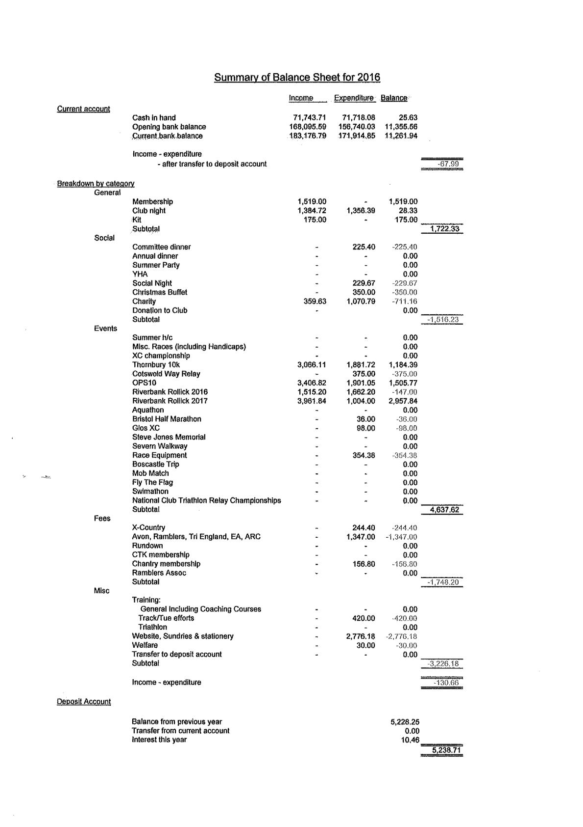

Appendix 3
Secretary’s Report for 2016

The Committee has met on seven occasions during the year, since last January’s AGM.

Membership
The calendar year closed with a total membership of 96 member, compared with 123 last year. There were 16 new applications (6M, 10F), which is the same as last year. The membership is split almost 50:50 between male and female.

Social Events
The club had one social event this year, a quiz night organised by Selina Slater

EA/ARC affiliation
The Club continues to be affiliated to England Athletics, the Association of Running Clubs and the Avon Athletic Association and renewed it’s subscription to the triathlon association
.
Despite giving free individual membership to English Athletics the club still only qualified for one marathon place. We had two applications for this place Kevin Cundy and Emma Brown, with Emma winning the ballot
Club Races
The Riverbank Rollick, Thornbury 10K and Oldbury 10 all went off very well again this year, thanks to the excellent work from our race directors. The Riverbank Rollick sold out once again sold out with 409 runners finishing the race. The Thornbury10K continues to grow with 291 finishers this year. The Oldbury Power Station also increased it’s entries and finishers .

Club Charity
The charity selected for 2016 was Meningitis UK. The Club will donate a total of £750 to the charity, largely from the surpluses generated at Club races.

Sue Carscadden

Appendix 4
Captains Report
The position of Captain has been problematical this year. Jim Godden took over from John Watt and started with great enthusiasm. His hope was to give a more competitive focus to the club. Jim’s work moved to Swindon and this made it difficult for him to get down to the club on a regular basis and in June he made decision to stand down as captain. Despite his tenure being short Jim’s captaincy did bring in several changes. He gave greater emphasis to flying the flag awards and introduced presenting prizes at club nights. Both these initiatives proved popular with the members and something I would like to continue if I am elected as Captain. Jim’s other initiative to get more members racing also appears to have paid dividends with a marked increase in members appearing in results over the year. The year started with 10 members running Doynton Hard Half Marathon and another 8 taking part in the Dursley Dozen. The club 10k championships races of Bradley Stoke, Frampton, and Berkley all proved popular, with 33 members taking part in at least one of these races. That’s a third of our current membership. Severn Bridge Half, Bristol half Weston Christmas Cracker also proved popular with members. It was also good to see the Severn Sisters Marathon back on the calendar for members.
We had 4 runners in the London Marathon and all athletes came in under 4hrs. With Rob Hopkins leading the way home in 03:06:33.
Park Runs continue to be popular with members. Looking through the result members have taken part in over 30 last year ranging from Aberystwyth to Lancaster, with Wotton, Chipping Sodbury and the now defunct Little Stoke proving the most popular.
Ultra-running continues to prove popular with members and who can forget the efforts of Ros Rowland, Dave Beard and Rob Hopkins in the Cotswold Way endurance race.
My personal highlight was the Cotswold Relay with the club putting out 3 teams, with the male vet teams finishing second once again. Hopefully they can go one better in 2017. I have already been in discussions with the committee to hire a minibus or two, to allow the club to give more support to the teams
I did not take on the role of Captain until October and thanks need to be given to Arthur Renshaw for standing in while the committee found a new Captain. My hope as captain was to bring runners together on a Thursday night with a mix of steady running with efforts incorporated into these runs. These sessions seem to be proving popular. I have been injured for almost 2 months and I must thank Emma and Mike Willis amongst others, for stepping in and taking these sessions while I have been injured.
Ros’s 5km Tuesday steady run group and Tuesday’s efforts session are proving popular, and thanks needs to be given to Ros and Craig for the work they do here.
The club races go from strength to strength. Numbers are up in both the Oldbury 10 and Thornbury 10km and the Rollick sells out earlier each year. These races make the club financially secure and it is good to see how well the members support our Race Directors. The Race Directors should also be congratulated for the time and effort they put into organising these races.
As you all know I am passionate about cross country, and it continues to disappoint me at the poor numbers we get for some races. To try and encourage more people to get involved I created a team competition at the recent Gloucestershire County Championships. This proved popular with over 20 runners taking part. Everyone seemed to enjoy it and there was a great club spirit. Hopefully this can continue into the 2017/2018 cross country season and we will see more members taking part in the leagues.

Finally I have enjoyed my short time as club captain and would like your support to continue in this role in 2017.
Pete Mainstone

